A201 Exercise—Step Size Exercise

AUTHORIZED RESOURCES: your instructor, your course notes, course materials and other cadets (but do not copy any of another cadet’s work)

Background:

Determining the correct step size to use in integration is very important. This exercise gives you the opportunity to examine the effects of changing the step size.

Use the Simulink model you created last lesson to do your analysis.

Tasks:

Add a “Display” module to the y component output.

Change the property of the Display module to “Format: short_e”

Go into the Configuration Parameters and select fixed step size, ode1 and a step size of 10. Run the model and record the final value.

Now repeat the process for step sizes of 1, 0.1, 0.01,…

Generate a plot with a logarithmic x-axis to see how close the solutions are.

Finally compare the final values with the “truth” value determined from:

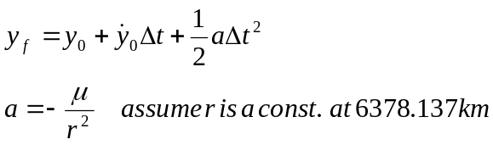

Note: You may fulfill this requirement by having the instructor verify your work by any of the following means:
- Signoff by viewing during class assigned -or-
- Bring hard copies to class for signoff

  - Plot With Logarithmic X-Axis

  - Truth Value

